PROFILE INFORMATION

Name : T.YASIKA  Designation : ASSISTANT PROFESSOR  Department : CIVIL ENGINEERING  Mail id : yasikathanaraj96@gmail.com |  | 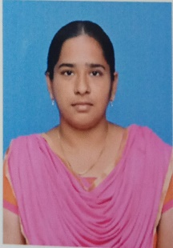
Qualification | M.E- Structural Engineering
Area of Interest | Structural Engineering
Industrial Experience | -
Research Guidance/ Teaching  Experience | -
Publications | - 2
Project Guidance | UG: -  PG: -  Ph.D:-
FDP /WORKSHOP/CONFERENCE | Attended: workshop: 2  Conference :-
Out Reach | Guest Lecture Given: -  As Judge : -  Other Roles : -
Membership In Professional Bodies | -
Certification | -
Accomplished NPTEL Courses | MODERN CONSTRUCTION MATERIALS
Awards & Accolades

